Your area of development  What area of development does this step concern? |  | N:o of this development step / form:
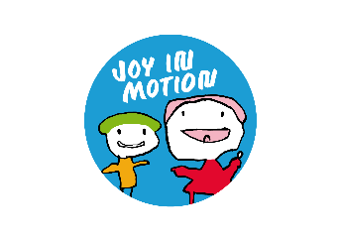
Early childhood education and care unit and municipality:

Baby steps form
Planning, implementation, assessment and improvements for one development step

- Plan the development step
Make a detailed and concrete plan for one development step. What do you plan to try? For the intended area of development, what is the initial situation before making the change? What are your objectives? How is the change being realised?
G

E

T

P

L

A

N

N

I

N

G
Development step, Baby step:
Initial situation (describe the situation before the development step): | Target situation (describe how the situation will look once the step has been realised - the results you are looking to achieve):
How will the development step be realised in practice (what will be done, how will it be carried out, who will do it, when):
When will we assess the realisation of our plan (i.e., when will we complete sections 3 and 4):

- Implement the planned development step

- Assess the implementation of your plan

Once you have carried out the planned actions, describe whether your plan was implemented as you imagined. Did you do everything in the way you planned? What happened? Also describe any possible difficulties, problems and unexpected impacts.

Describe the results / changes according to indicators. Compare the results to the initial situation and target situation. Did you achieve your target situation? What was successful and what, if anything, was unsuccessful? What did you learn? Was the change an improvement?

Summary of the results and changes brought about by the implemented step:

- Consider what improvements are still needed and begin planning the next step
What conclusions have you made? What changes should still be made to the activities based on the information from your initial efforts? What will you try next?

Our conclusions:

What will we try next? How will we move forward from this point?

